**Aligning molecular and microscopy methods in detecting biofouling species in the plankton and on kelp**

**Calum Young, Eleni Christoforou, Martin Llewellyn, Maria Alguero-Muniz, Victoria Delannoy, Kayla Orr, Sofie Spatharis**

**Introduction**

Kelp cultivation offers significant potential as a sustainable marine bioresource, capable of advancing global food security, mitigating climate change and delivering high-value products across medical, agricultural and industrial sectors (Sultana et al., 2023, Jagtap and Meena, 2022, Duarte et al., 2021). Although Asian producers have long dominated global seaweed markets, emerging expansion within regions like the North-East Atlantic demonstrates the rising international interest for macroalgae production (Veenhof et al., 2024, Zhang et al., 2022). Seaweed farming is critical to the EU’s sustainable blue economy which aims to increase production to 8 million tonnes by 2030, creating 85,000 jobs and generating an estimated 9 billion Euros of revenue (Jueterbock et al., 2025). However, there are significant barriers to commercial viability for Europe’s seaweed industry which is predominantly made up of small-scale startups (Addamo et al., 2022). Limitations in infrastructure, high productions costs and inconsistent biomass qualities that meet market demand hinder industry expansion and broader market access (Holland and Shapira, 2024).

Biofouling by proliferating epibionts remains a major constraint on the commercial viability of seaweed aquaculture (Bannister et al., 2019). The cold, mesotrophic waters of the North-East Atlantic which are ideal for macroalgal cultivation, also provide optimal conditions for seasonal proliferation of damaging fouling organisms (Forbord et al., 2020). These taxa, including bryozoans, hydrozoans, gastropods, amphipods, bivalves, tunicates and epiphytic algae, colonize the blades of both wild and farmed seaweed Impairing seaweed health and reducing commercial value (Matsson et al., 2019).

Fouling organisms compromise host seaweeds in three major ways: through physical damage, physiological disruption, and competition for vital resources (Bannister et al., 2019). Encrusting species such as bryozoans reduce light penetration, hinder nutrient and gas exchange, and block reproductive spore release; factors culminating in tissue necrosis (Walls et al., 2017). Biofouling also reduces frond flexibility which increases hydrodynamic drag. This leads to breakage and detachment in wave-exposed environments, ultimately reducing harvestable biomass (Krumhansl et al., 2011). As infestation severity increases, the quality, taste, and market value of the crop declines, this is concurrent with rising processing costs and allergen risks for consumers (Walls et al., 2017; Bannister et al., 2019). To avoid peak biofouling, many farmers are forced to harvest early, sacrificing both yield and profitability (Visch et al., 2020).

The structure of epibiont communities differs significantly depending on location and host seaweed species resulting in site-specific impacts on cultivated seaweeds. For instance, *Saccharina latissima* and *Alaria esculenta* exhibit similar biofouling successional patterns, closely matching Wahl’s (1989) model of epibiosis (Forbord et al., 2020). This process begins with the deposition of a thin organic film, followed by bacterial colonization and the establishment of diatom biofilms. These early stages are largely dictated by the physicochemical properties of the host surface (Wahl, 1989). As succession progresses, algal spores and invertebrate larvae settle and dominate the epibiotic community, particularly hydrozoans and bryozoans, (Ronowicz et al., 2008; Rolin et al., 2017). For example, bryozoans form calcified mat-like colonies that significantly alter the ecological structure of the host surface (Førde et al., 2015), while hydrozoan colonies may themselves provide substrate for other fouling taxa, creating a complex, multi-layered biofilm (Tendal and Dinesen, 2005).

A critical phase in this process is the meroplanktonic stage, during which larvae disperse through the water column before settling on substrates such as macroalgae, rocks, or aquaculture infrastructure (Agostini and Ozorio, 2022). In the Northern Hemisphere, fouling is most intense from spring through autumn, driven by seasonal changes in temperature, light availability, and water movement (Visch et al., 2020). However, the strength and nature of these environmental drivers vary by location and depth, affecting the timing, intensity, and species composition of fouling events (Rolin et al., 2017; Matsson et al., 2019; Pratt et al., 2022). Key variables influencing larval settlement and fouling risk include temperature, salinity, wave exposure, and photosynthetically active radiation (PAR) (Handå et al., 2013; Bruhn et al., 2016; Forbord et al., 2020).

Larval duration and overwintering capacity also shape fouling dynamics. For example, the bryozoan *Membranipora membranacea* produces larval cyphonautes that can persist in the water column for several weeks to months before settlement (Ryland and Stebbing, 1971). Overwintering colonies can act as a larval source for early spring fouling events (Menon, 1972). Førde et al. (2015) documented year-round presence of these larvae in North Atlantic waters, noting a sharp increase in abundance from late June onward. The timing of colony establishment was closely aligned with peak larval density, possibly due to elevated temperatures stimulating reproductive output or a general increase in seasonal plankton productivity.

Epibiosis tends to be more severe on farmed than wild kelp, partly due to higher growing densities with lower genetic diversity and the synchronous growth of monocultured crops (Matsson, 2021). In contrast, wild kelp forests exhibit greater species heterogeneity, asynchronous phenology, which may provide resistance to colonisation (Wiencke and Bischof, 2012). Additionally, wild kelp grows from the seafloor, where wave action and contact with hard substrates dislodge larvae via whipping a motion, reducing settlement. Cultivated kelp is suspended on ropes and lacks this natural defence. Furthermore, farm ropes often remain in the water year-round. It is possible that this may act as reservoirs for fouling larvae, enabling colonisation once the blades reach sufficient size. This highlights the potential vector role of infrastructure in biofouling dynamics.

Quantitative microscopy of water samples allows for identification and enumeration of problem epibionts during the larval stages (Agostini and Ozorio, 2022). As such, plankton surveys serve as a valuable detection method of biofouling risk prior to the visual appearance on seaweed crops. Detection of seasonal peaks in larva abundance allows farmers to anticipate infestation severity of subsequent blade colonisation and enable adaptation of time management strategies. However, microscopy is labour-intensive and requires strong taxonomic expertise that could still miss cryptic or rare taxa (Chen et al., 2023).

Metabarcoding of environmental DNA (eDNA) from seawater samples enables even earlier detection of epibiont communities by identifying genetic material shed into the surrounding environment by organisms, often before they become detectable through microscopy (Zaiko et al., 2016; Djurhuus et al., 2018). Amplification of targeted barcode regions from eDNA can reveal epibiont presence weeks before colonisation may become visible on blades (Rishan et al., 2023; Keck et al., 2022).  A commonly used marker in marine metazoan metabarcoding is the mitochondrial cytochrome c oxidase subunit I (CO1) gene, which provides species-level resolution for many invertebrates (Borrell et al., 2017). However, with metabarcoding, challenges remain with taxonomic gaps and detection inconsistencies, particularly in low abundance species due to amplification biases caused by primer selectivity (Algueró‐Muñiz et al., 2024).

Integrated analysis of molecular data alongside physical observations enables investigation into the temporal lags between meroplanktonic larvae within the water column and their subsequent physical settlement upon the seaweed substrate. While metabarcoding has proven effective in community composition studies, its potential as a tool for early detection is increasingly evident as it offers broad taxonomic resolution and ability to detect often overlooked or cryptic species. By aligning molecular reads with visual observations such as planktonic counts and blade colony assessments, it becomes possible to generate a more holistic understanding of biofouling dynamics. Collectively, this can improve the accuracy and reliability in using molecular read data within biofouling monitoring frameworks.

**Methods**

Methods overview

We combined eDNA metabarcoding, plankton‐net microscopy counts, and visual surveys of blade‐attached epibionts to undertake both descriptive and comparative analyses addressing three core objectives: 1) Method comparison: Quantify and contrast the sensitivity and taxonomic resolution of molecular (eDNA) versus microscopy‐based approaches in detecting epibionts both in the water column and on kelp blades. 2) Temporal dynamics: Characterize time‐lags among eDNA signal emergence, planktonic epibiont detections, and their subsequent settlement on seaweed fronds. 3) Depth distribution: Evaluate how epibiont colonization intensity varies along blade depth gradients. Fig. 1 represents the combined methodological framework utilized within this study.

Figure 1. Methodological Framework: Overview of the study approach and objectives.

*Site and Sampling: Farm layout, coordinates*

*Saccharina and Alaria*

*Zooplankton and Phytoplankton microscopy*

*Microscopic Identification of Blade Epibionts*

Several of the epibionts were identified on the blades via rope scrubbing, a method that involved scraping biofouling organisms from cultivation ropes that are submerged in the water column prior to macroalgal seeding.

*Blade epibiont barcoding*

A total of 24 epibiont specimens were collected from Kelpcrofters Seaweed Farm (Isle of Skye) between June 2021 and January 22. Samples were preserved in 95% ethanol and stored at -20oC until processing. Genomic DNA was extracted using Qiagen DNeasy® Blood and Tissue Kit according to manufacturer’s protocol. Extracted DNA was quantified with a Qubit™ Fluorometer and diluted to a concentration of 1.3ng/μl prior to submission for Sanger sequencing (University of Dundee) Resulting sequences were trimmed and aligned using BioEdit Sequence Alignment Editor. Taxonomic identification was performed through BLAST searches within the NCBI GenBank database, using criteria of ≥97% sequence similarity, amplicon lengths >80 bp, and the lowest E-value for species assignment. Sequences that failed to meet these criteria were omitted. Identified taxa were subsequently compared with results from visual surveys conducted using a stereomicroscope.

Plankton eDNA

*Data Analysis*

**GLMs packages etc**

**Results**

*Barcoding analysis for the detection of kelp epibionts*

DNA barcoding greatly improved the resolution and accuracy of epibiont identifications, relative to traditional microscopy. Table 1 shows several taxa which were not confidently identified above the taxonomic level of order during visual surveys but were successfully identified to species level using barcode sequencing. For example, *Caprella mutica* and *Jassa herdmani* were both confidently identified with 100% sequence identity, while microscopy was unable to distinguish them beyond the broader taxonomic group. Similarly, hydrozoan taxa such as *Ectopleura larynx*, *Bougainvillia muscus*, and *Clytia hemisphaerica* were all allocated to species level by barcoding despite being recorded only as “Hydroid” or left unclassified in plankton and blade microscopy.

Several barcoded taxa including *Caprella mutica*, *Jassa herdmani*, *Hiatella arctica*, *Ectopleura larynx*, and *Bougainvillia muscus* were also recorded from rope scrubs, indicating that these species may establish on farm infrastructure prior to kelp blade development. Notably, *Hiatella arctica*, a bivalve only identified via its juvenile form in microscopy, was confirmed through barcoding at 97.7% identity and detected on ropes, supporting the interpretation of rope colonisation as a precursor to blade settlement.

*Assessing the efficiency of eDNA vs microscopy in detecting the planktonic stages of kelp epibionts*

Comparisons between eDNA and microscopy datasets demonstrated consistent detections of several epibiont taxa in planktonic eDNA which were not identified via microscopy. For example, *Celleporella hyaline* (bryozoa) and *Hiatella arctica* (Bivalvia)were both confirmed as biofoulers via blade sample DNA barcoding (*Table 1*) and were both detected in the water column through eDNA analysis, while remaining entirely absent from plankton net microscopy counts (*Fig. 2 and 4*). Bryozoan eDNA signals appeared as early as May and peaked in June and July (2022), this closely preceded visible colonisation on *Saccharina* blades (Fig. 2). In contrast, *Alaria* blades showed no bryozoan colonisation throughout the entirety of the study.

Signals from eDNA for bryozoan and hydrozoan groups appeared earlier and more consistently than the corresponding microscopic detections. In plankton tows, Hydrozoa could only be identified to the class level, highlighting the limited taxonomic resolution of microscopy. In contrast, eDNA metabarcoding detected strong and recurrent signals for *Bougainvillia muscus* and *Clytia sp.*,identifying them, to species and genus level, respectively (*Fig. 3*). Both of which were also confirmed epibionts from blade scraping and subsequent barcoding analysis (Table 1). These taxa showed a clear seasonal emergence in mid-June and persisted at high eDNA abundance into July (Fig. 3). Blade fouling by hydrozoans was substantially higher on Saccharina, relative to Alaria which exhibited considerably lower hydrozoan colonisation. Additionally, of the main taxa investigated, hydrozoa produced the largest diversity of species identified via CO1 metabarcoding (25), followed by gastropods (22), bivalves (5), bryozoans (3) and amphipods (3).

Plankton microscopy identified bivalve larvae only at the class level (Fig. 4). In contrast, eDNA signal detection patterns identified four distinct species with variable seasonal peaks. Notably, *Hiatella arctica*, a burrowing bivalve barcoded from blades and found rope scrubs was identified through eDNA well before its physical presence was recorded on *Saccharina* fronds (Table 1;Fig. 4). eDNA signals for bivalves began rising in early summer, with peak detections in June for *Dosinia sp.* This preceded a marked increase in blade settlement densities. Blade colonisation was again more prominent on *Saccharina* than on *Alaria*, with the former showing greater overall densities and a longer colonisation window.

Amphipod detections showed a similar trend to that of bryozoa and hydrozoa. *Caprella mutica* and *Jassa herdmani* were confidently identified through blade specimen barcoding and eDNA reads (Fig. 5). Both species were however not identified in any plankton samples via microscopy. Their eDNA presence became notable by late June, increasing steadily into July, concurrent with observed blade settlement.

Gastropods also illustrated the added resolution of eDNA. Microscopy identified gastropods only to the class level, with no seasonal differentiation achievable. In contrast, eDNA revealed sustained detection from May through July (Fig. 6), and blade barcoding confirmed *Doto coronata* as a frequent biofouler. As with other groups, *Saccharina* hosted more frequent and diverse gastropod colonisation, whereas *Alaria* had limited gastropod presence across the season.

**Table** 1. Summary of epibiont taxa identified and the highest taxonomic resolution achieved by each method: visual identification from blades, planktonic microscopy surveys, and DNA barcoding of individuals sampled from blades. Percentage value (%) denotes percentage identity match of sequence with with GenBank database. Rope scrub presence (Y/N) denotes taxa identification from scrubbing of farm ropes prior to seaweed seeding.

|  |  |  |  |  |
| --- | --- | --- | --- | --- |
| Epibiont ID | Plankton ID | Barcode ID | Rope Scrub Presence | Photo |
| Amphipoda (Caprellidae) | NA | *Caprella mutica* (100%) | Y |  |
| Amphipoda (Caprellidae) | NA | *Jassa herdmani* (100%) | Y |  |
| Amphipoda (Jassa) | NA | *Jassa herdmani* (100%) | Y |  |
| Bryozoans (cf Celleporella hyalina) | Cyphonaute | *Celleporella hyalina* (98.79%) | N |  |
| Clam juvenile | Bivalvia | *Hiatella arctica* (97.7%) | Y |  |
| Dendronotid sea slug (Doto) | Gastropod | *Doto coronata* (99.62%) | Y |  |
| Electra pilosa | Cyphonaute | *Electra pilosa* (97.3%) | Y |  |
| Hydroid (Tubulariidae) | NA | *Ectopleura larynx* (100%) | Y |  |
| Hydroid (with Licmophora attached) | NA | *Bougainvillia muscus* (99.41%) | Y |  |

|  |  |  |  |  |
| --- | --- | --- | --- | --- |
| Epibiont ID | Plankton ID | Barcode ID | Rope Scrub Presence | Photo |
| Hydroid (with Licmophora attached) | Clytia sp. | *Clytia hemisphaerica* (99.59%) | Y |  |
| Hydroid (with Licmophora attached) | NA | *Bougainvillia muscus* (99.41%) | Y |  |
| Hydroid (with Licmophora attached) | Clytia sp. | *Clytia hemisphaerica* (99.59%) | Y |  |
| Membranipora membranacea | Cyphonaute | *Membranipora membranacea* (99.60%) | N |  |
| NA | Balanoid nauplii | *Amphibalanus improvisus* (100%) | N |  |
| Obelia sp. | Obelia sp. | Obelia dichotoma (99.67%) | N |  |
| Rhodophyta (Pterosiphonia spinifera) | NA | Pterothamnion plumula (98.86%) | Y |  |
| Unidentified | NA | Laminaria digitata (99.6%) | Y |  |
| Unidentified algae (with Licmophora attached) | Hydroid | Bougainvillia muscus (99.41%) | Y |  |

*Assessment of time lags between eDNA , plankton and blade settlement of epibiont taxa*

*Bryozoa*

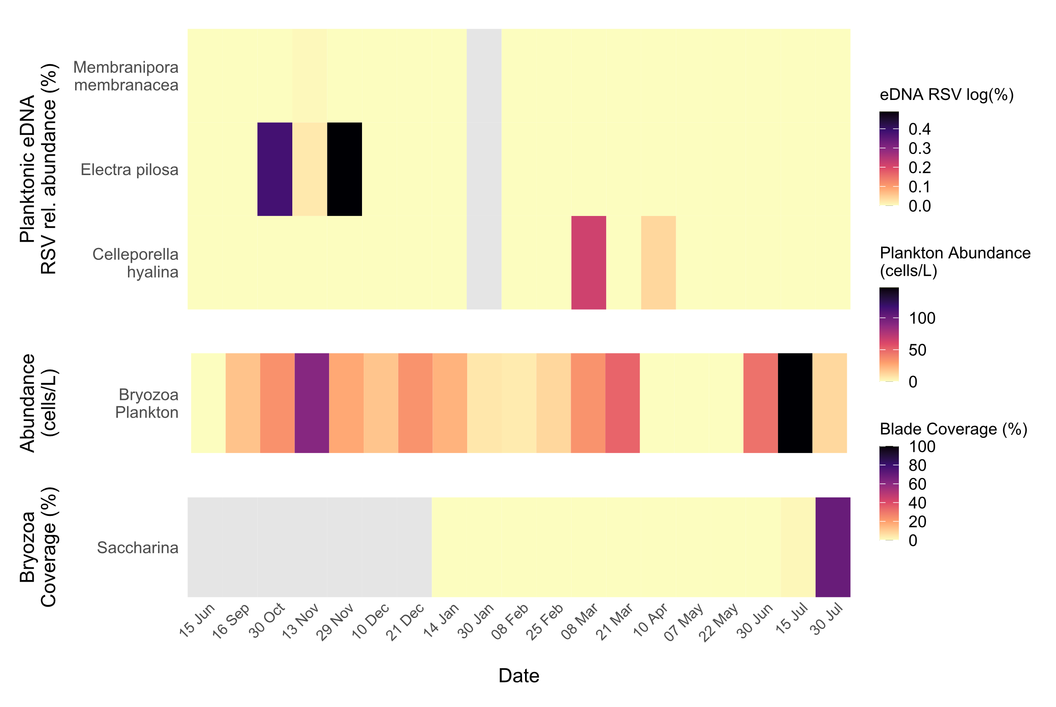

**Figure 2**. Temporal dynamics of Bryozoa epibionts. Heatmaps showing the seasonal patterns of bryozoan detection by eDNA metabarcoding, plankton microscopy, and blade settlement on cultivated kelp. Colours indicate log-transformed relative sequence variant (RSV) abundances (%), plankton cell counts (cells/ L); and percent coverage (%) of bryozoan colonies on Saccharina blades. No blade dectections of bryozoan species were recorded on Alaria. Sampling dates span 15 Jun 2021 to 30 Jul 2022. All values are monthly averages calculated from three independent replicate samples per date.Grey shading marks data unavailable.

*Hydrozoa*

**Figure 3.** Heatmaps showing the emergence and settlement of Hydrozoa detected by eDNA metabarcoding, plankton microscopy, and blade fouling on two kelp hosts. Colour intensity represents relative abundance of log RSV (%) from eDNA read samples, plankton abundances (cells/ L); and percent blade coverage (%) measured separately on Saccharina and Alaria. Sampling dates span 15 Jun 2021 to 30 Jul 2022. All values are monthly averages calculated from three independent replicate samples per date. Grey shading marks data unavailable

**Figure 4.** Heatmaps illustrating bivalve detection and colonization over time by relative abundance of eDNA RSV log (%) in the water column, plankton microscopy counts (cells/ L), individual density (ind/cm²) on Saccharina blades, and individual density on Alaria blades. All values are monthly averages calculated from three independent replicate samples per date. As before, sampling dates run from mid-June 2021 to end-July 2022, and grey bars indicate periods without data.

*Amphipoda*

**Figure 5.** Heatmaps representing seasonal patterns of amphipod detection and settlement by eDNA metabarcoding (log RSV %), plankton‐net microscopy counts (cells/L), and blade colonization abundance (individuals/cm²) on Saccharina and Alaria fronds. All values are monthly averages calculated from three independent replicate samples per date. Sampling dates span mid-June 2021 to late-July 2022, and the grey-shaded areas mark indicate periods without data.

*Gastropoda*

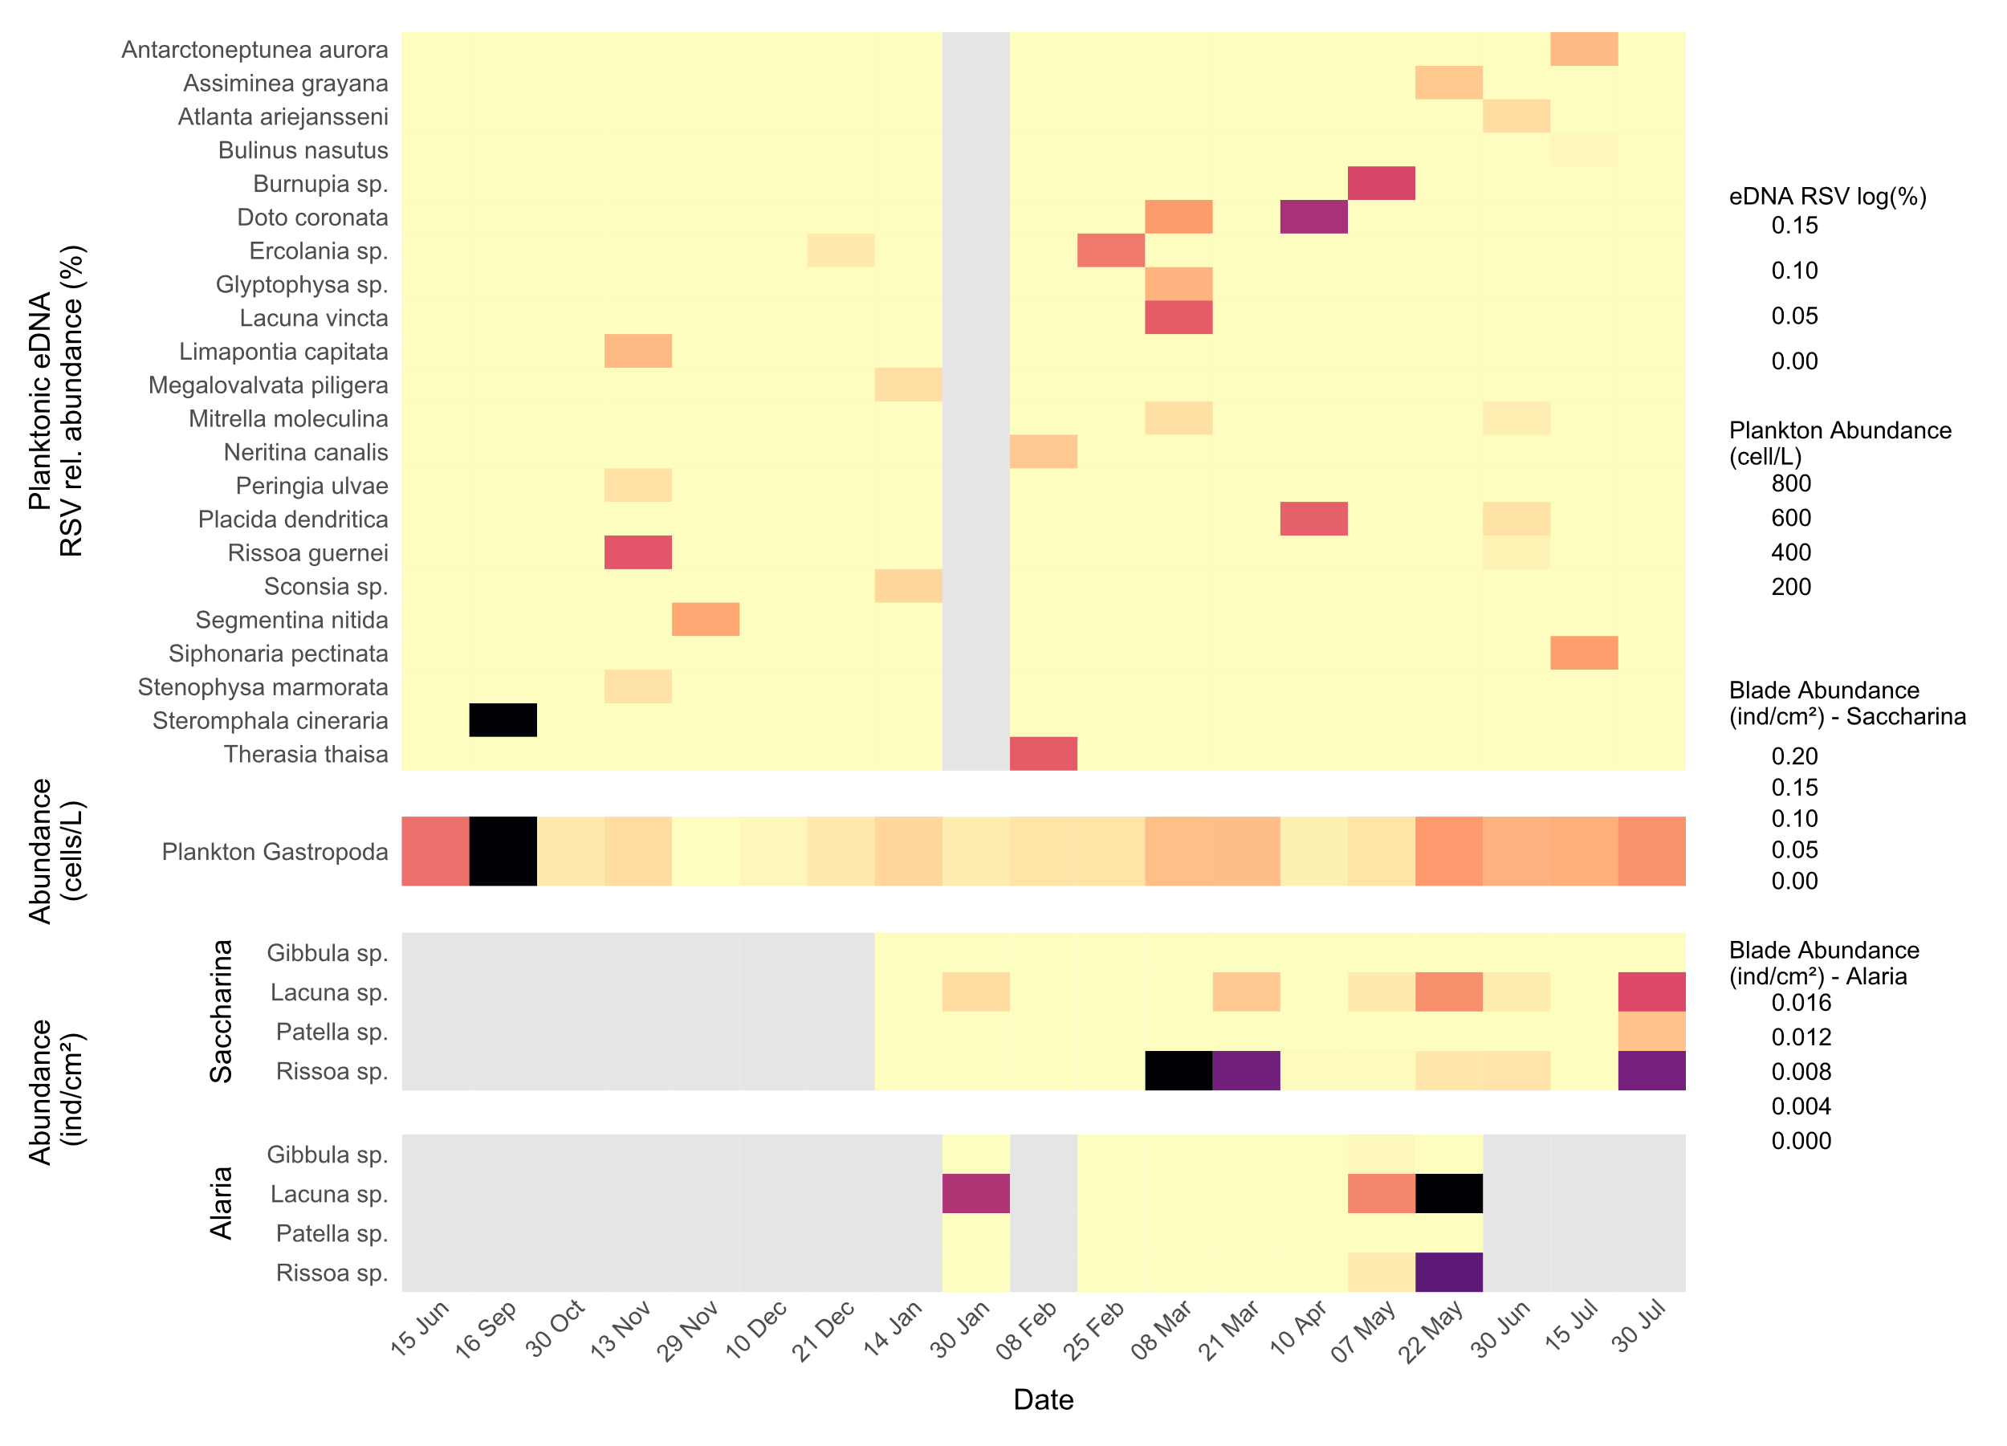

**Figure 6** Heatmaps illustrating seasonal emergence and settlement of gastropods detected by eDNA metabarcoding (RA log RSV %), planktonic abundance (cells/L), and blade settlement abundance (individuals cm⁻²) on Saccharina blades. All values are monthly averages calculated from three independent replicate samples per date. Sampling dates run from mid-June 2021 through late-July 2022, and grey shading denotes periods without data.

*Temporal Composition of dominant zooplankton taxa*  
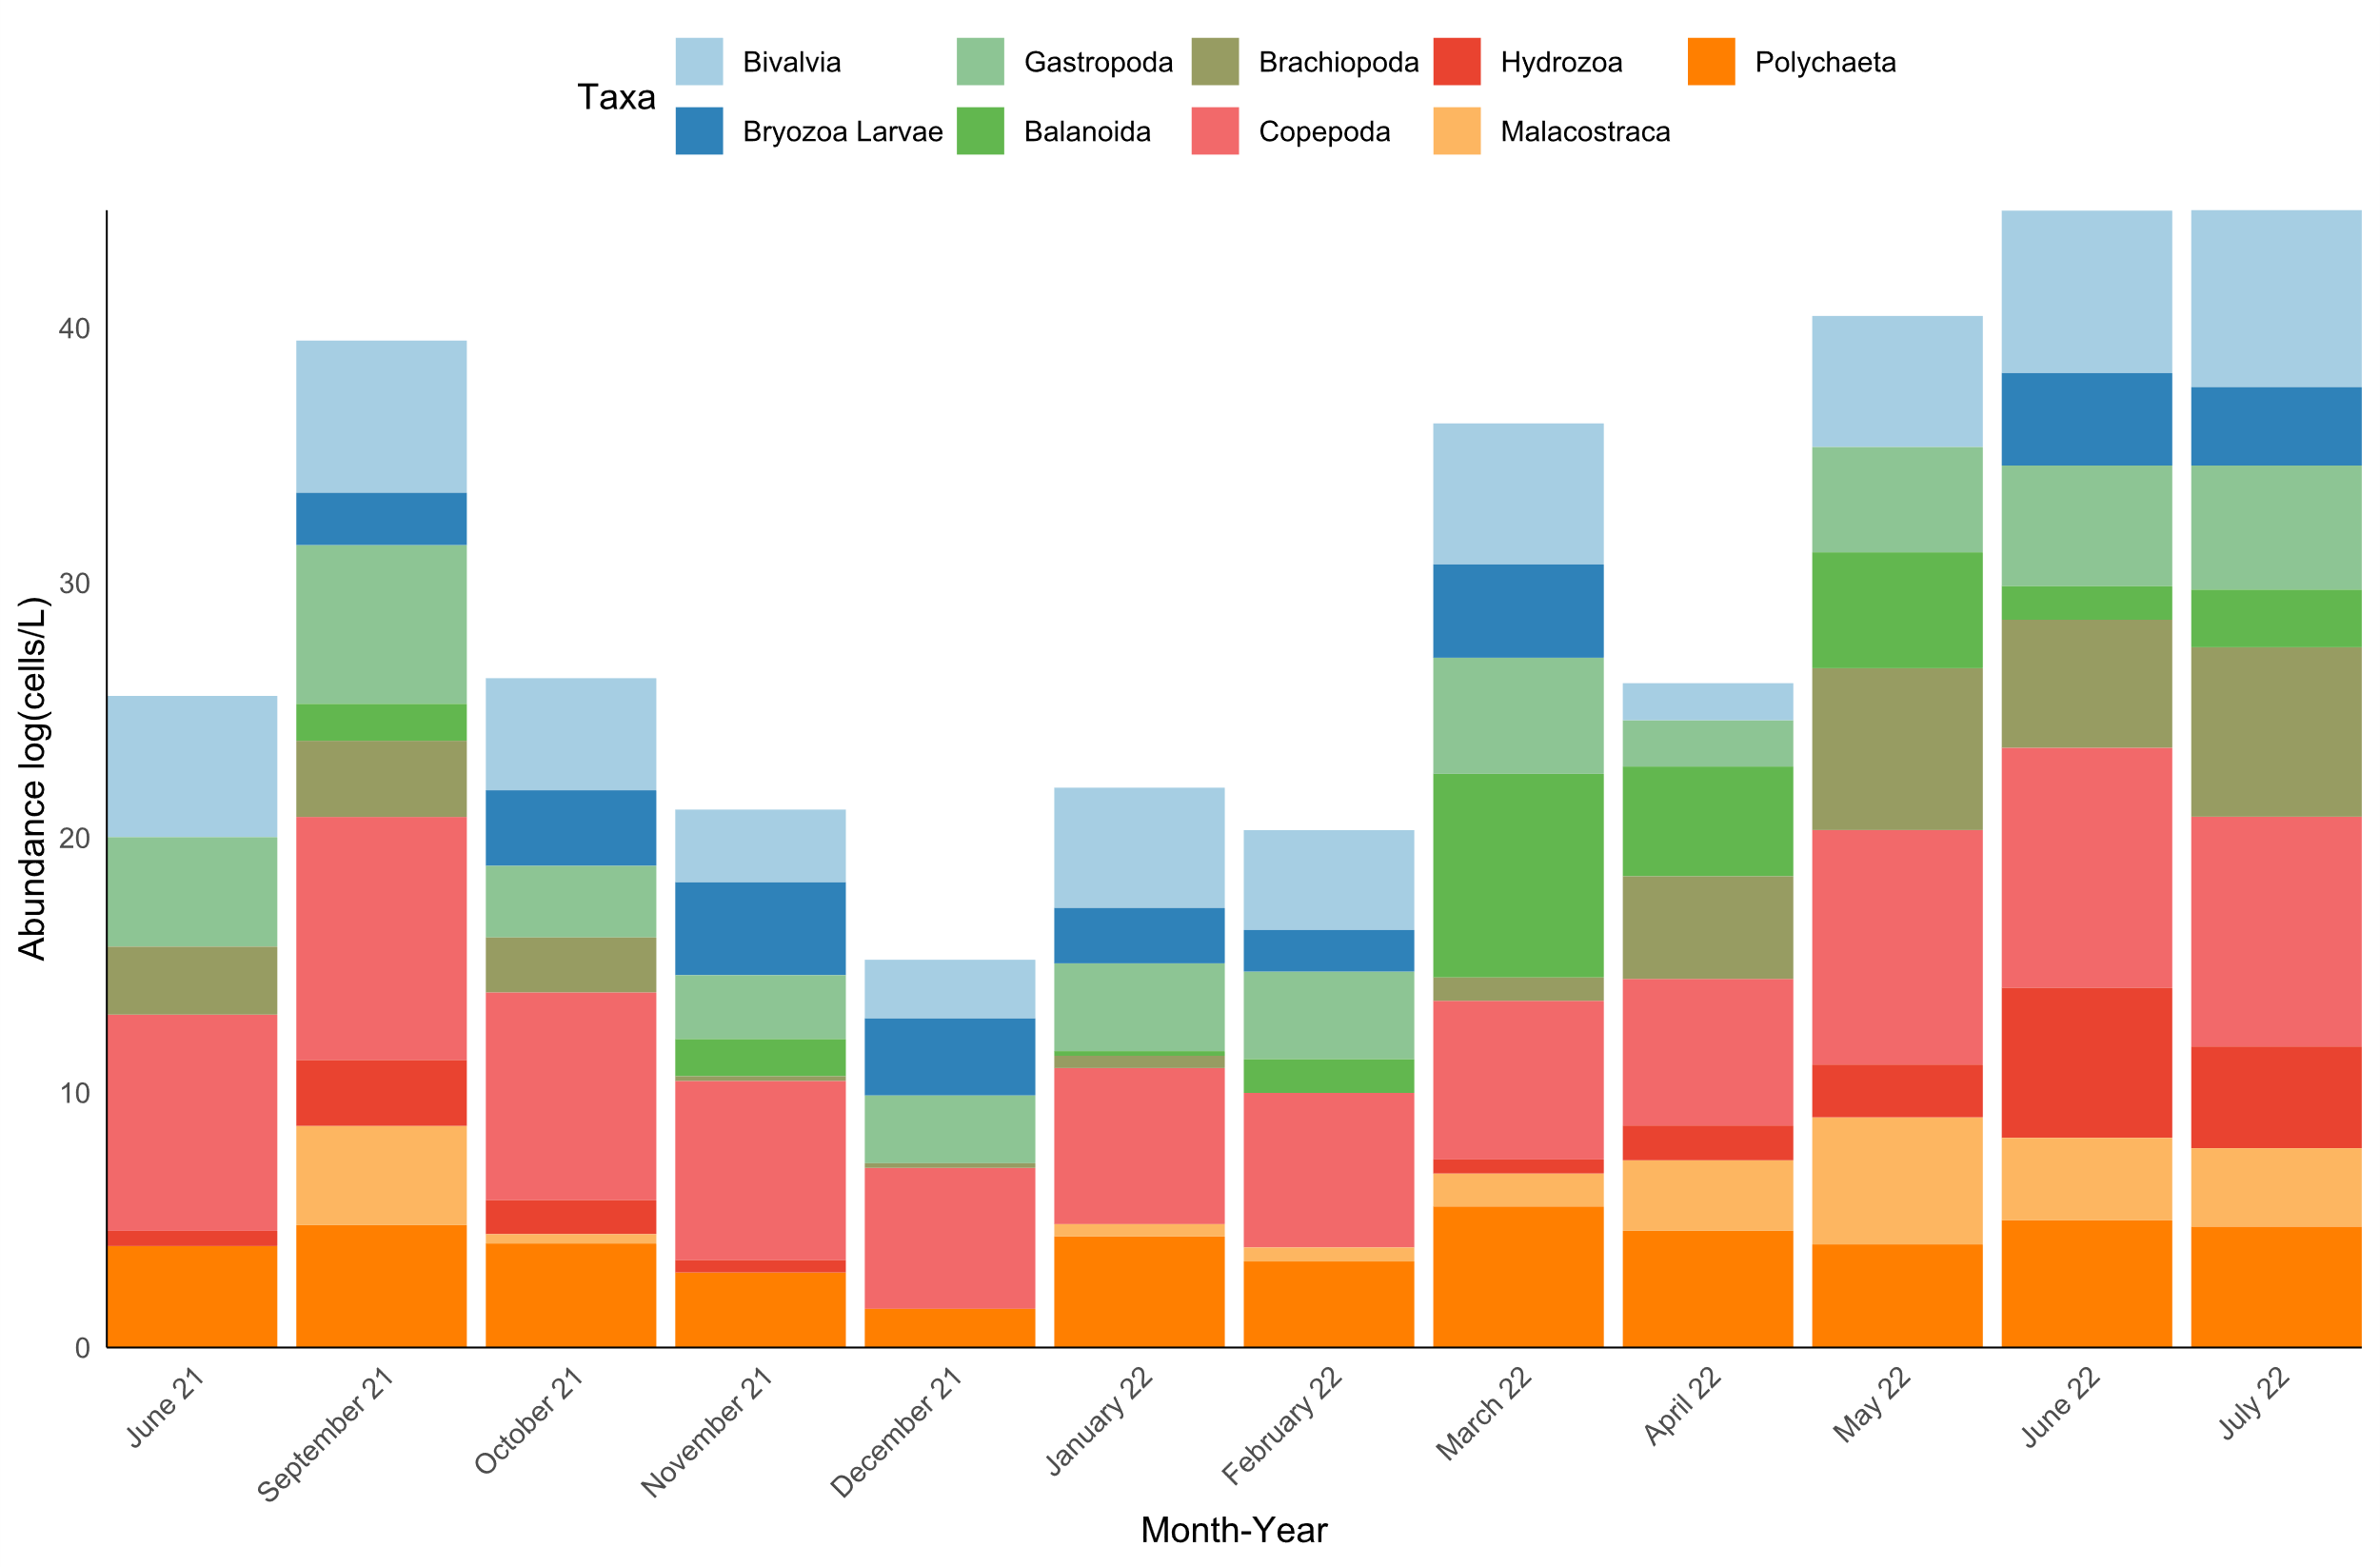

**Figure 7**. Stacked bar chart showing the mean monthly log-transformed abundances (cells/ L) of the principal planktonic groups collected by plankton net from June 2021 through July 2022 from Pabay, Isle of Skye. Coloured segments indicate contributions from Copepoda, Malacostraca, Polychaeta, Bivalvia, Bryozoa larvae, Gastropoda, Brachiopoda, Hydrozoa, and Balanomorpha (see legend). Seasonal shifts in community composition are evident in the varying heights and segment proportions of the monthly bars.

Figure 7 illustrates the seasonal variation in abundance and composition of the dominant zooplankton taxa sampled via plankton tow at Pabay, Isle of Skye, between June 2021 and July 2022. Mean monthly abundances (log-cells/L) reveal distinct seasonal shifts in community structure during the sampling period.

*Biofouling blade coverage of Alaria and Saccharina*

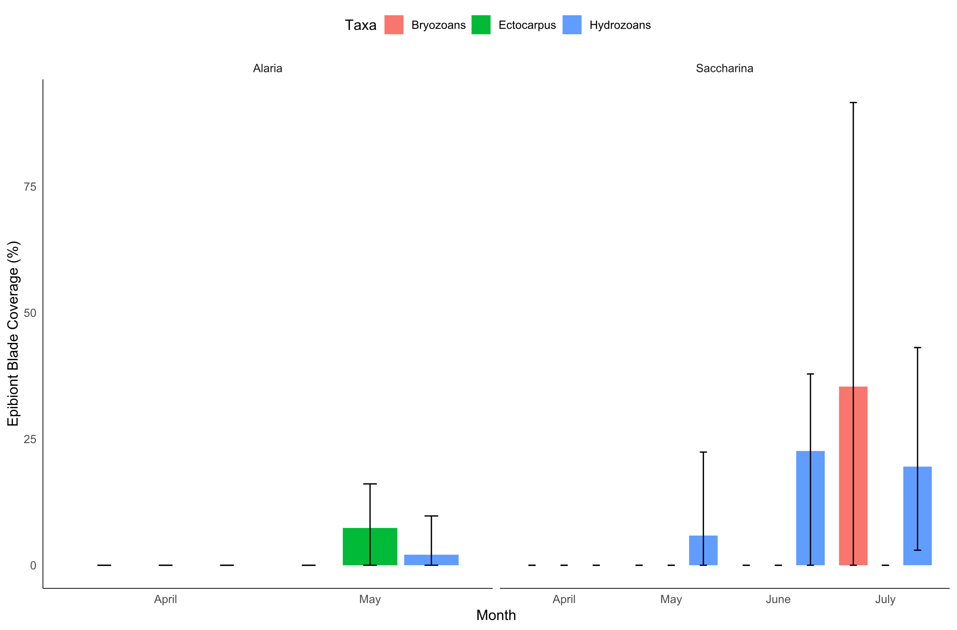

**Figure 8.** Bar charts showing mean percent blade surface covered by three epibiont groups—Bryozoans (red), Ectocarpus (green), and Hydrozoans (blue)—from April through July 2022. Error bars extend from the minimum to maximum observed coverage across replicate blades. Alaria fouling only recorded in May (no June or July data available), whereas Saccharina exhibited negligible coverage in April–May followed by substantial hydrozoan and bryozoan colonization in June–July.

*Biofouling blade colonisation of Alaria and Saccharina*

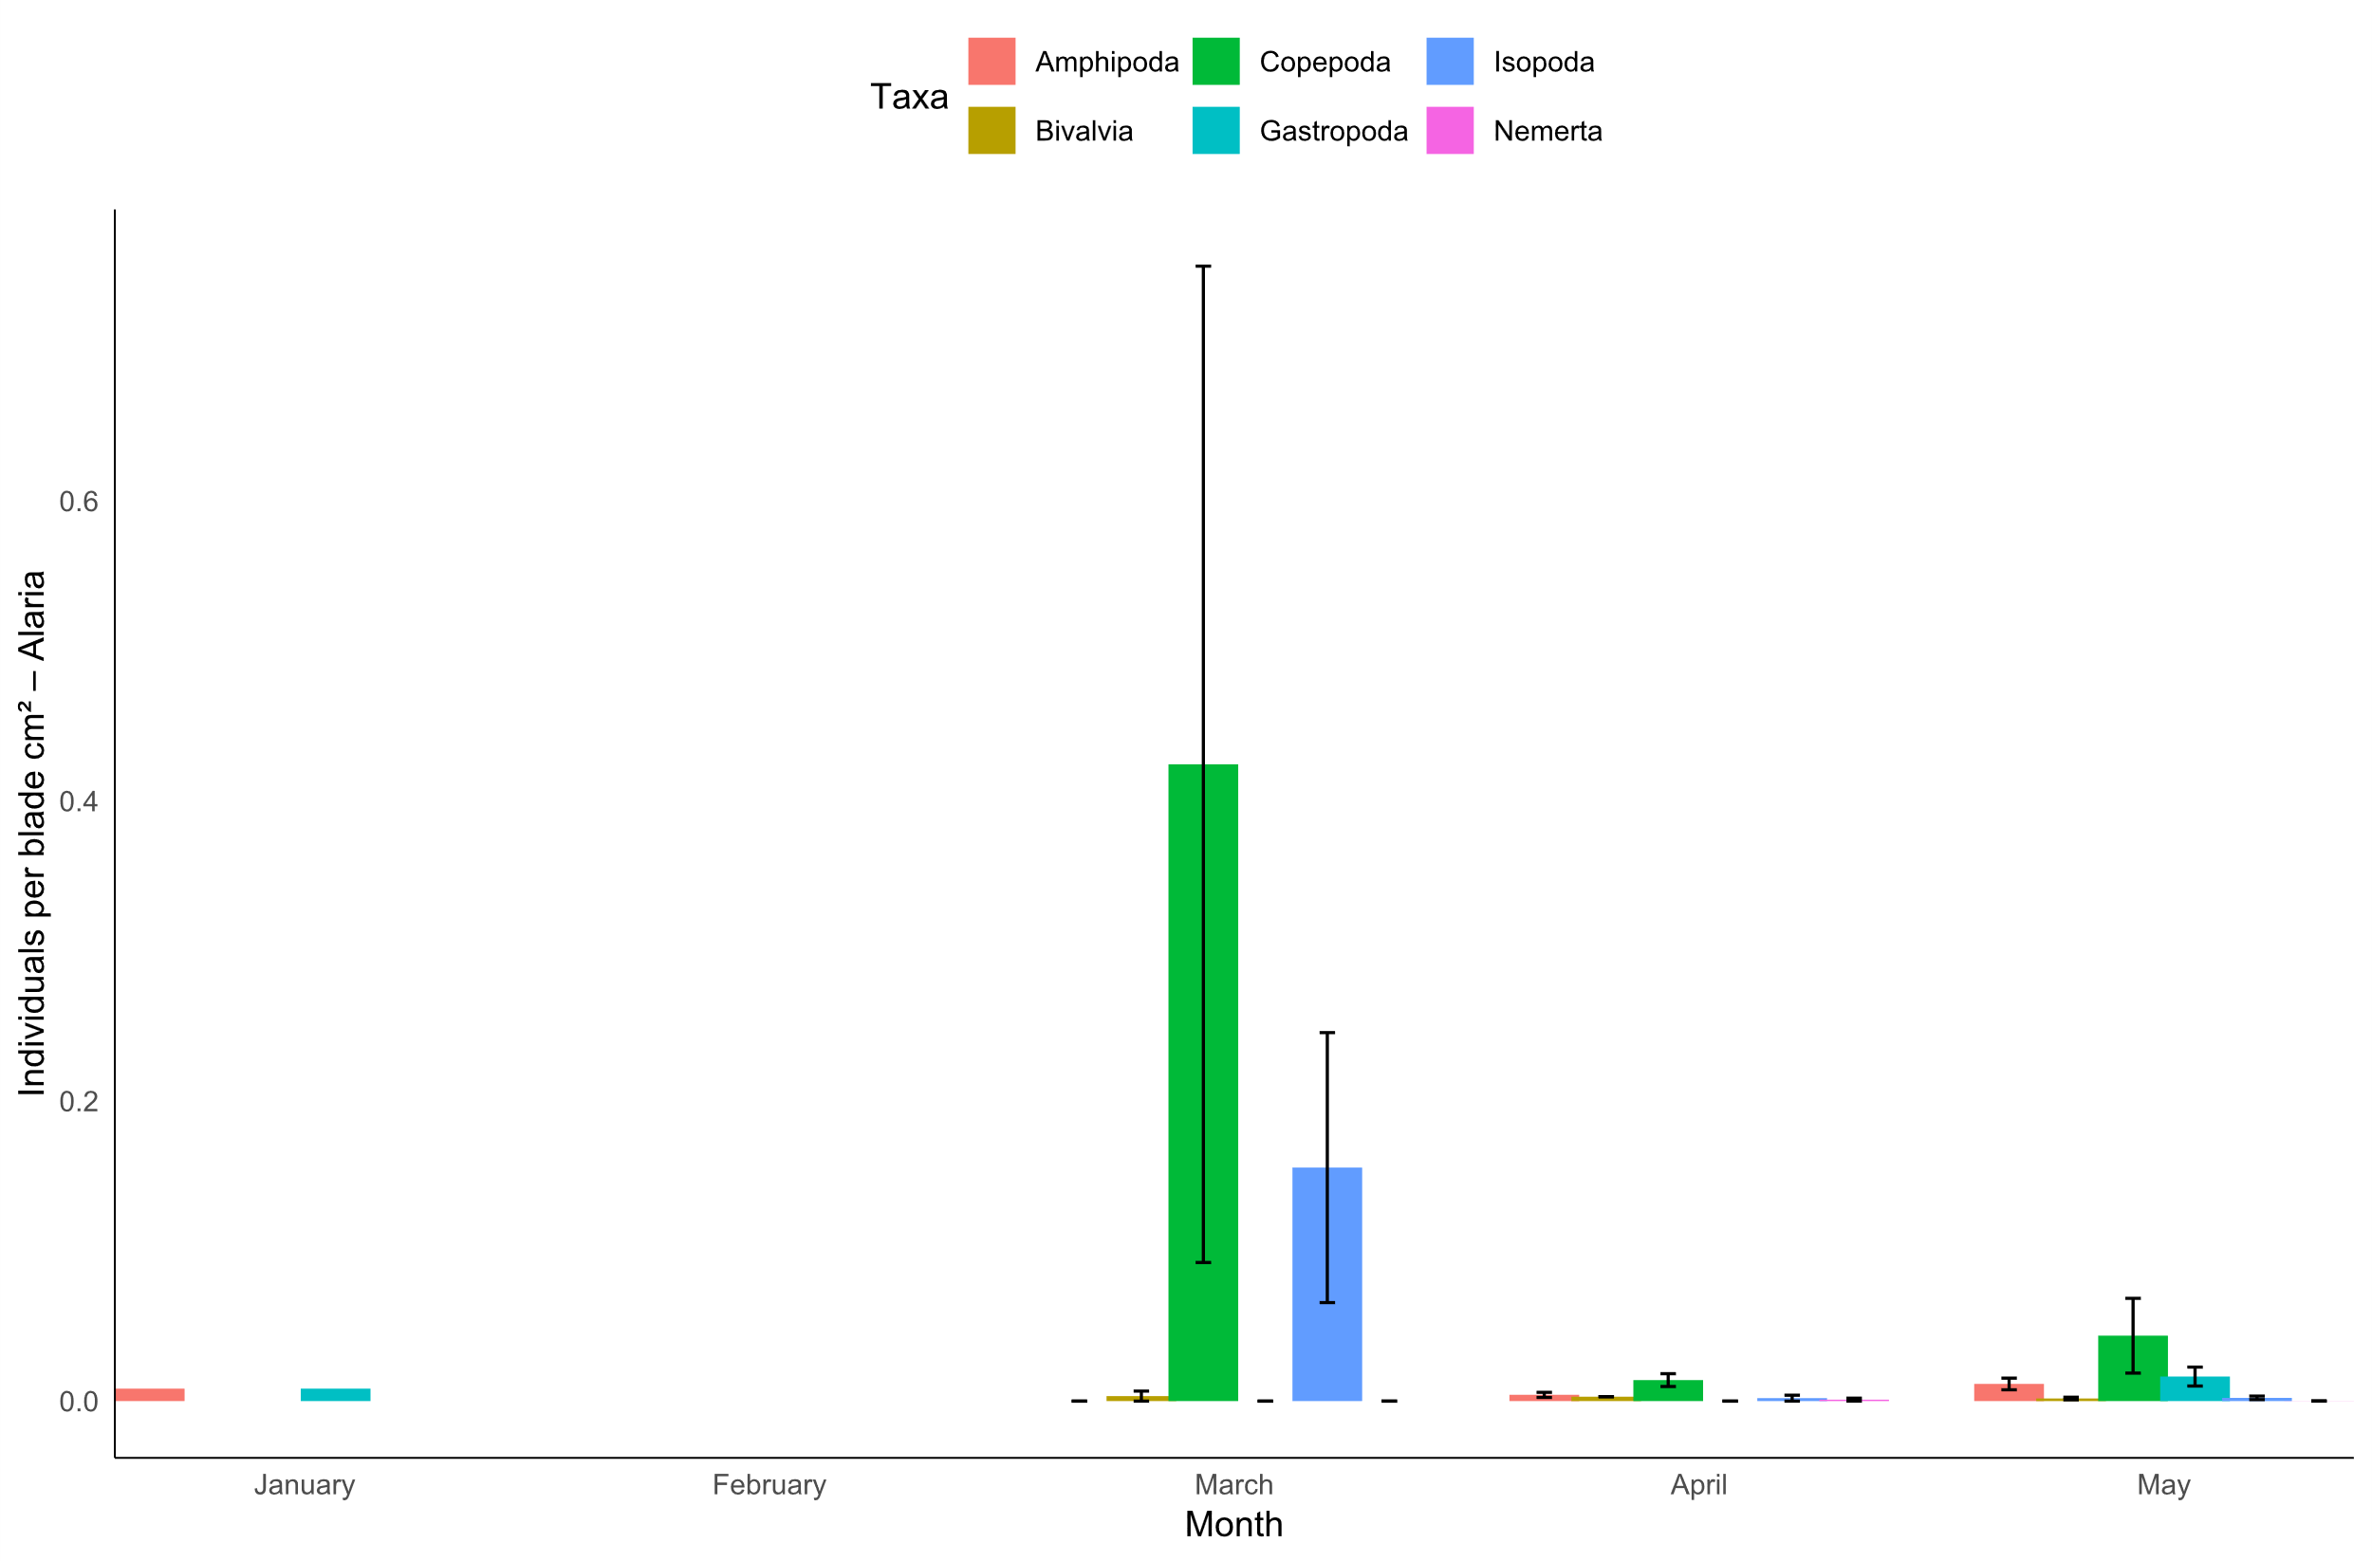

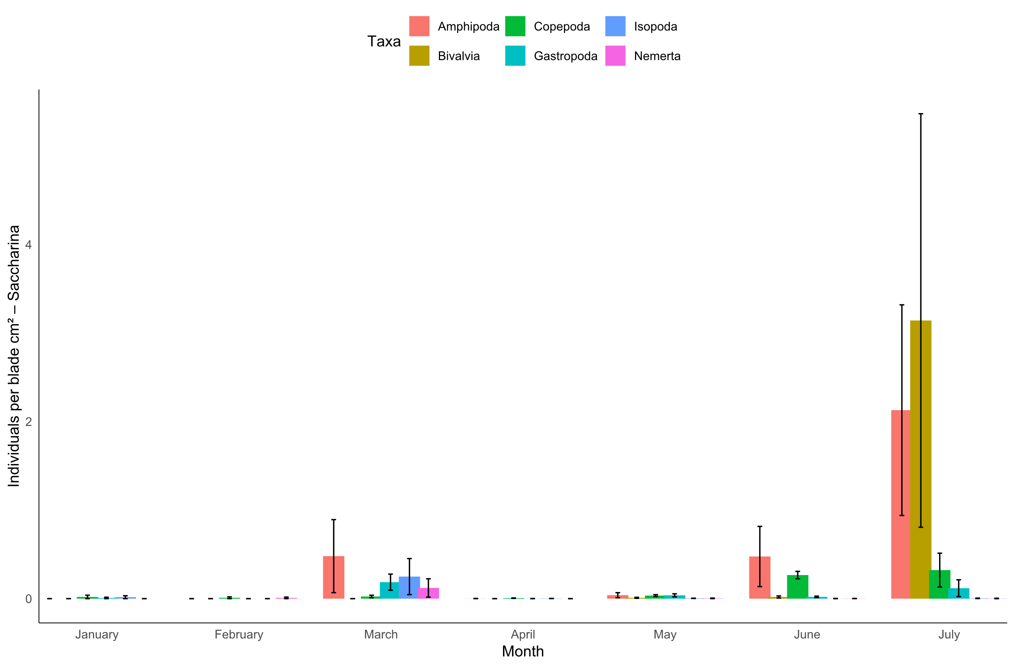

Figure 9. Bar charts showing mean colonization density (individuals /cm²) of six major taxa—Amphipoda (red), Copepoda (green), Isopoda (blue), Bivalvia (gold), Gastropoda (teal), and Nemertea (magenta)—on Alaria (top) and Saccharina (bottom) blades from January to July 2022. Error bars span the minimum to maximum values among replicate blades. On Alaria, peak copepod and isopod settlement occurs in March, with negligible densities before and after; on Saccharina, low-level settlement from January–June is followed by more pronounced amphipod and bivalve colonization in July.

*Depth effect on epibiont distribution on seaweed blades*

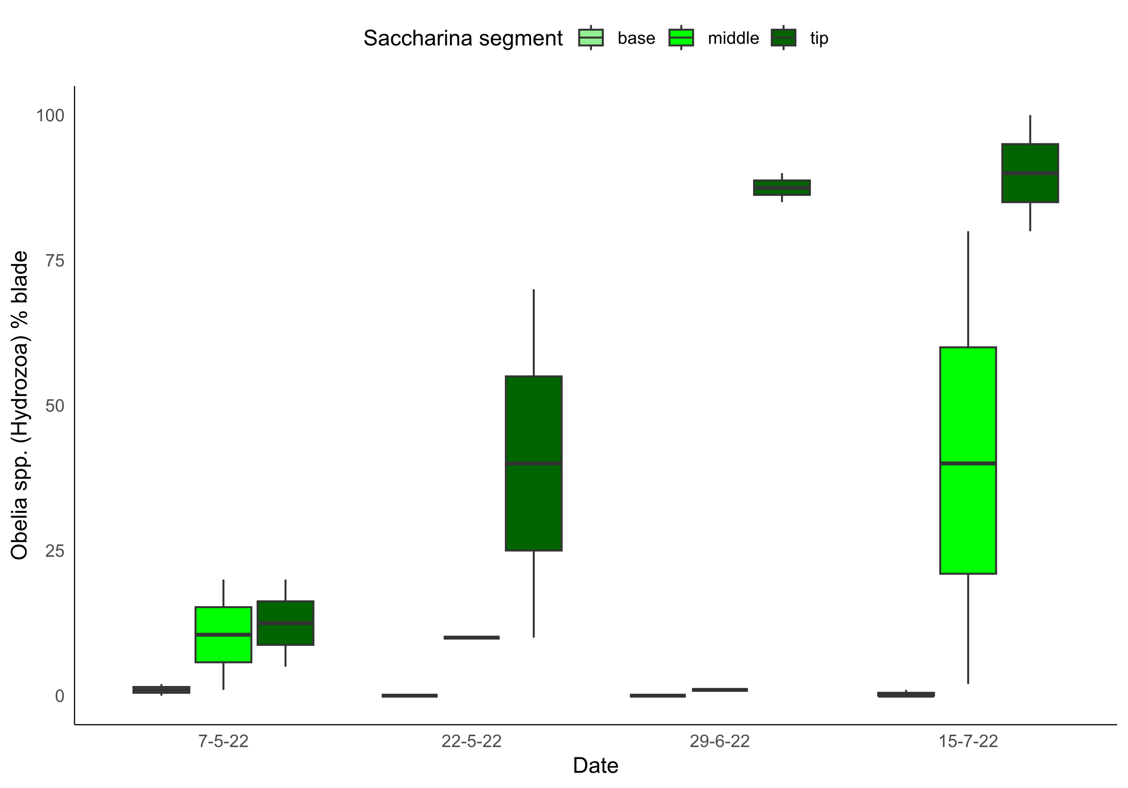

**Figure 10.** Boxplots of the percentage of blade area covered by Obelia spp. (Hydrozoa) on three blade segments—base (light green), middle (green), and tip (dark green)—sampled on 7 May, 22 May, 29 June and 15 July 2022. Colonization was essentially zero on the basal segment throughout the season, appeared first and most moderately on the mid‐blade by late May (median ~12 %), and quickly surged on the tip segment, rising from ~30 % coverage in late May to >85 % by late June and nearly complete (>90 %) by mid‐July. This pattern highlights both the rapid seasonal increase in hydrozoan fouling and the strong depth‐related gradient of epibiont settlement along the kelp blade.

Two-way ANOVA showed that hydrozoan coverage was significantly influenced by blade segment depth (F₂,₁₉ = 12.93, *p* < 0.001) and also varied significantly across sampling dates (F₃,₁₉ = 3.44, *p* < 0.05).

**Discussion**

*Barcoding analysis for the detection of kelp epibionts*

This temporal relationship indicates that epibionts may colonise farm ropes and remain there until blades have grown to a suitable size for colonisation. Farming operations may benefit from cleaning ropes or removing lines from the sea altogether prior to seeding to mitigate their reservoir/vector effect.

*Assessment of time lags between eDNA , plankton and blade settlement of epibiont taxa*

Microscopic identification of species can be difficult due to strong morphological similarities among species and life-stages. However, the integrated use of DNA barcoding and BLAST sequence analysis provided considerably enhanced taxonomic resolution. For example, *Hiatella arctica* and *Celleporella hyalina* were confidently identified from high-percentage barcode matches, despite limited plankton identification. This molecular approach not only corroborated physical detection methods but also provided insight into species that may otherwise go unnoticed using microscopy alone. Overall, integrating visual data with barcoding reveals key species affecting seaweed farms and ultimately advances the understanding of biofouling dynamics.

No bryozoa at all on *Alaria* – species-specific susceptibility

Notably, the nudibranch, *Doto coronata*, which is commonly associated with hydroid prey was identified through barcoding from blade material with 99.6% sequence identity (ref). Although undetected in the plankton by microscopy, its presence in the eDNA dataset indicates that larvae or free-floating DNA from this species was present in the water column prior to blade colonisation. This suggests that eDNA metabarcoding not only improves detection of gastropod epibionts at earlier life stages but also captures species that are easily missed in morpho-taxonomic surveys due to their cryptic or delicate forms. These findings reinforce the complementary value of integrating molecular tools alongside microscopy to better characterise the full diversity and temporal dynamics of biofouling gastropods in aquaculture environments.

*Depth effect on epibiont distribution on seaweed blades*

This suggests that sugar kelp biofouling activity by *Obelia sp.* is driven by depth and time. This may be due to colonisation being favoured by a more stable water column microenvironment. For example, reduced light penetration, turbulence and potentially higher nutrient availability may contribute to hydrozoan proliferation. Segments deeper in the water column would have less mechanical disturbance from wave action further enabling sustained polyp growth.

Furthermore, seaweed growth occurs as the base/meristem while older tissue at the tips continually sheds (Mann, 1973). The distal blade segment represents the oldest, most established surface. The increased colonisation at the tip may be resultant from the tissue being more withered or structurally compromised due to longer exposure to environmental stressors thus heightening susceptibility to infestation. More simply, the tip section of the frond has existed the longest and therefore has had the greatest exposure time, providing more opportunities for settlement events and colony expansion. These combined physical and biological factors offer a plausible explanation for the consistently higher levels of biofouling observed at the blade tips. However, further targeted investigation is needed to disentangle the relative contribution of each factor and determine whether a single dominant driver or a synergistic combination is primarily responsible for hydrozoan colonisation patterns.